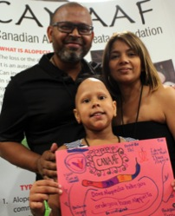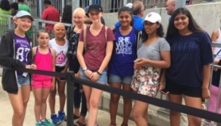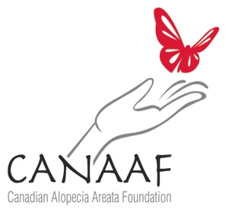 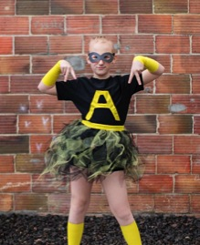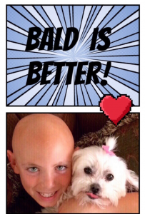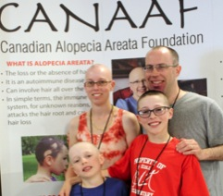 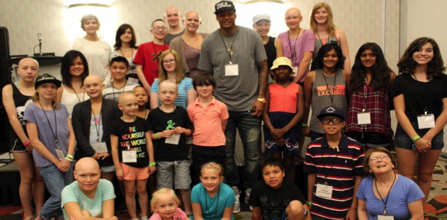

We have Alopecia But Alopecia doesn’t have US! - Charlie Villanueva

Cha

**DONATE NOW** [www.canadahelps.org/en/charities/canadian-alopecia-areata-foundation/](http://www.canadahelps.org/en/charities/canadian-alopecia-areata-foundation/)

**Or By Cheque To** CANAAF227 Burton Grove   
King City, Ontario L7B 1C7

**VOLUNTEER WITH US!**

**CONTACT US**

Website CANAAF.org

Email [info@CANAAF.org](mailto:info@canaaf.org)

## Information for Schools

## *Predictable…*

## *For an Unpredictable Disease*

## ELEMENTARY

## &

## HIGH SCHOOL

CANAAF.org

Canadian Registered Charity No. 80224 3493 RR0001

**IN THE CLASSROOM**

Teachers, work with the kids, caregivers and families to help create a supportive and accepting classroom environment. Bullying and name-calling frequently come from lack of understanding or fear of the unknown.

Students have created comic books, written speeches and created presentations to share Alopecia Awareness with their classmates. However, be mindful that not all children wish to share their diagnosis; be cautious not to single out Kids and Teens with Alopecia.

**SCHOOL ADMINISTRATION**

Alopecia can be a devastating diagnosis. Care and support are required. Kids and teens with Alopecia are able to participate in every activity at school, however some accommodations may be necessary. Some kids and teens with Alopecia prefer to have their heads covered at some point during the school day. This is both for physical and physiological comfort. Follow the student’s lead and respect their wishes. It is important that all staff members are made aware of why wearing a hat, scarf or wig during school is important and should be tolerated. No child with alopecia should be asked to remove their headwear, at any time.

@alomissmak

**SCHOOL GUIDANCE DEPARTMENT**

Please feel free to contact CANAAF for more information. We’d love to have volunteers help while accumulating hours for graduation.

info@CANAAF.rg

**SCHOOL FUNDRAISERS AND AWARENESS EVENTS**

CANAAF would love to help your school spread the word about Alopecia! Let us know if you plan on hosting an awareness event or fundraiser. We can send

**Conferences and Awareness Events**

Join others with alopecia at various events. Information posted online. Email [info@CANAAF.org](mailto:info@CANAAF.org) to join our mailing list.

# WHAT IS CANAAF?

Alopecia isn’t contagious, but AWARENESS can be! Spread it around!

**WHAT IS ALOPECIA?**

Alopecia is an autoimmune disease that involves the loss or absence of hair, not only on the scalp, but all over the body as well. The immune system, for unknown reasons, attacks the hair root and causes hair loss. Alopecia affects approximately 1 to 2% of the population, and is highly unpredictable and often cyclical. Occasionally nail changes, such as ridges or pitting, may also occur. Typically there is no discomfort associated with alopecia although increased skin sensitivity has been reported.

**WHO IS AFFECTED?** Alopecia can occur in both males and females. Most often this begins in childhood, but can occur at any age. Alopecia does not differentiate by race. Alopecia may resolve spontaneously within weeks or be recurrent over a lifetime.

**IS ALOPECIA GENETIC?** Statistics show that in one of five persons with alopecia someone else in the family may also have it. There may also be other autoimmune diseases that affect family members.

ISA

The Canadian Alopecia Areata Foundation was established in 2009.

CANAAF supports those affected by alopecia Areata, promotes awareness and education of this autoimmune disease and raises funds for research.

We are a Canadian Registered Charity made up of a volunteer Board of Directors and volunteer Support Group Leaders across Canada.

Other Resources: ProjectJesse.com [childrensalopeciaproject.org](https://childrensalopeciaproject.org) NAAF.org @alomissmak @CVBelieve

<https://www.projectjesse.com/downloads/comic.pdf> (Used with permission)

“Duis at neque eu ligula vehicula feugiat.”